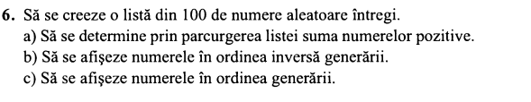

#include <iostream>

#include<time.h>

#include<stdlib.h>

#define MAX_NUM 100

using namespace std;

struct num

{

int nr;

};

int main() {

int n = 100, random, sum = 0, sumn = 0;

num list[n];

srand(time(NULL));

for (int i = 1; i <= n; i++)

{

random = rand() % MAX_NUM;

list[i].nr = random;

}

for (int i = 1; i <= n; i++)

{

if (list[i].nr >= 0) sum += list[i].nr;

else if (list[i].nr <= 0) sumn += list[i].nr;

}

cout << "a) Suma numerelor pozitive din lista : " << sum << endl;

cout << "a*) Suma numerelor negative din lista : " << sumn << endl;

cout << endl << "b) Lista generata in ordine inversa : " << endl;

for (int i = n; i >= 1; i--)

{

cout << list[i].nr << " ";

}

cout << endl;

cout << endl << "c) Lista in ordinea generarii : " << endl;

for (int i = 1; i <= n; i++)

{

cout << list[i].nr << " ";

}

return 0;

}

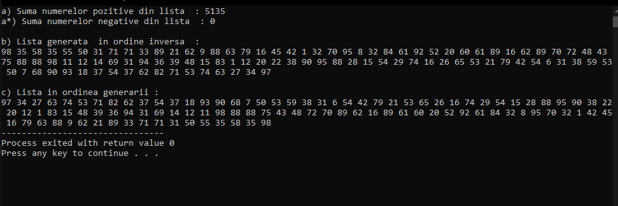

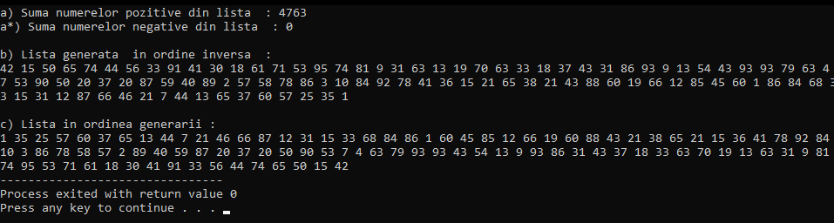

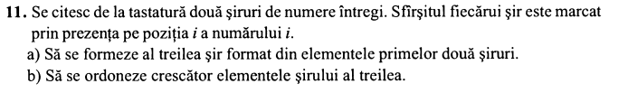

#include<iostream>

using namespace std;

struct read_array_response {

int x[100];

int length;

};

typedef struct read_array_response array;

array read_array(string s) {

array res;

int i = 0;

cout << "Introduceti "<< s << " sir: ";

do {

i++;

cin >> res.x[i];

} while(res.x[i] != i);

res.length = i;

return res;

}

array append(array x, array y, int start = 0) {

x.length += y.length;

for (int i = 1; i <= y.length; i++) {

x.x[i + start] = y.x[i];

}

return x;

}

void swap(int *xp, int *yp)

{

int temp = *xp;

*xp = *yp;

*yp = temp;

}

void bubbleSort(int *array, int size) {

for(int i = 1; i<=size; i++) {

int swaps = 0;

for(int j = 1; j<=size-i-1; j++) {

if(array[j] > array[j+1]) {

swap(array[j], array[j+1]);

swaps = 1;

}

}

if(!swaps)

break;

}

}

void print_array(array x) {

for (int i = 1; i <= x.length; i++) {

cout << x.x[i] << " ";

}

}

int main() {

array a, b, c;

a = read_array("primul");

b = read_array("al doilea");

cout << "Sirul concatinat este: " << endl;

c = append(c, a, 0);

c = append(c, b, a.length);

print_array(c);

cout << endl << "Sirul sortat este: " << endl;

bubbleSort(c.x, c.length);

print_array(c);

}

